CREATIVE CYBER SOLUTIONS

WEBSITE SYSTEM DESIGN DOCUMENT

Design By:   
Cody Connor

John Bell   
Yadira Despaigne

© 2018 CONNOR, BELL, DESPAIGNE

Table of Contents

Introduction ………………………………………………………………………. 2

Description ………………………………………………………………………. 2

User Experience Design …………………………………………………….. 3

* Existing Website Design …………………………………………….. 3
* Updated Website Design Mock-Up ……………………………………. 4
* Problems with Current Reservation System …………………………… 5
* Problems with the Current User Interface …………………………… 6
* Navigation Hierarchy for New Website ………………………….... 7

System Requirements ……………………………………………………... 10

* Functional Requirements …………………………………………….. 10
* Non-Functional Requirements ……………………………………. 11
* Implementation Requirements ……………………………………. 11
* Supportability Requirements …………………………………………….. 11

Data Design ………………………………………………………………………. 13

* Entities …………………………………………………………….... 13
* Attributes ………………………………………………………………. 13
* Conceptual ERD ……………………………………………………… 15
* Logical ERD ………………………………………………………………. 16

Use Cases ……………………………………………………………………….. 17

* Rental Lookup System Use Case …………………………………….. 17
* Reservation System Use Case …………………………………….. 17
* Account System Use Case ……………………………………………… 18
* Content Management System Use Case ……………………………. 18
* Customer Relationship Management System Use Case …………… 19
* Reporting System ………………………………………………………. 19

Use Case Diagrams ……………………………………………………………….. 20

* Rental Lookup System Use Case Diagram …………………………….. 20
* Reservation System Use Case Diagram …………………………….. 21
* Account System Use Case Diagram ……………………………………… 22
* Content Management System Use Case Diagram ……………………. 23
* Customer Relationship Management System Use Case Diagram ….. 24
* Reporting System Use Case Diagram …………………………….. 25

Introduction

This term we will be re-creating the Creative Cyber Solutions website. The new website will be styled different and have bugs fixed. The way your website impact clients at first site is what will determine their decision to choose your service. The company would like to get a chance to gain potential clients to help the business grow, not only locally but, globally.

Intended audience

CCS is intending to use Enterprise Resource Planning (ERP) systems for businesses that need to integrate areas such as planning, purchasing, inventory, sales, marketing, finance and human resources.

Team members’ responsibility

Cody – Designer and programmer

John – Programmer

Yadira – Programmer

**User Experience Design**

Updated Website Design Mock-Up

Navigation Hierarchy

**System Requirements**

Functional Requirements

* The system shall allow visitors to:
  + Navigate through the main pages
  + View offered services
  + Contact Creative Cyber Solutions with inquiries
  + View the members of the Creative Cyber Solutions team
  + Register
* The system shall allow registered users to:
  + Navigate through the main pages
  + View offered services
  + Contact Creative Cyber Solutions with inquiries
  + View the members of the Creative Cyber Solutions team
  + Log in and Log out
  + Send messages
  + View sent and received messages
  + View his/her projects
  + Request projects
  + View invoices
* The system shall allow administrators to:
  + Navigate through the main pages
  + View offered services
  + Contact Creative Cyber Solutions with inquiries
  + View the members of the Creative Cyber Solutions team
  + Log in and Log out
  + Send messages
  + View sent and received messages
  + View all clients’ projects
  + Request projects
  + Add new projects
  + View all products
  + Add products to projects
  + Add notes to projects
  + Add new products
  + View registered users list
  + View each user’s account
  + Delete user accounts

Non-Functional Requirements

* The system must be reliably accessible across multiple devices.
* The website needs to be aesthetically appealing with the aim of generating potential clients.

Implementation Requirements

* The system must use C# with the ASP.NET CORE 2 MVC Framework
* The system needs to use secured networks for transferring customer information
* The system will rely on a MSSQL Server RDBMS
* The system must encrypt and hash database content whenever possible to maximize the security of customer information
* The system will use HTML, CSS, jQuery, and Bootstrap to support its UX design and responsive design elements
* WCAG2 & 508 Accessibility Compliance

Supportability Requirements

* The system will be set up and tested by the development team.
* The system needs to require little or zero maintenance or upkeep as the initial agreement does not include a maintenance or support plan.
* All content and associated functions need to be editable and manageable by the on-site administrator with the client company.
* Basic instruction on how to restart the web server system in case of minor faults will be necessary for client self-administration, along with basic troubleshooting tips.
* Provide available resource list to the client so they have direction to in the event the system needs updated or upgraded.

**Data design**

New System Entities:

* User
* Note
* Project
* Product
* ProjProd
* Message
* Settings

New System Attributes

User table

* ID PK
* Firstname
* Lastname
* Email
* Username

Note table

* ID PK
* ProjectID FK
* Date
* From
* FromName
* Test
* Visible

Project table

* ID PK
* CustomerID FK
* From
* FromName
* Test
* Visible

Product table

* ID PK
* Active
* Name
* Price
* Quantity

ProjProd table

* ID PK
* ProjectID FK
* ProductID FK
* Quantity

Message table

* ID PK
* FromID FK
* ToID FK
* Date
* FromName
* Parent
* Status
* Subject
* Test
* ToUser

Settings table

* ID
* ContactEmail
* ContactLogin
* ContactPassword
* ContactPort
* ContactSMTP
* InvoiceDays
* InvoiceStatus
* MsgDays
* ProjDays
* WelcomeMessage

Logical ERD

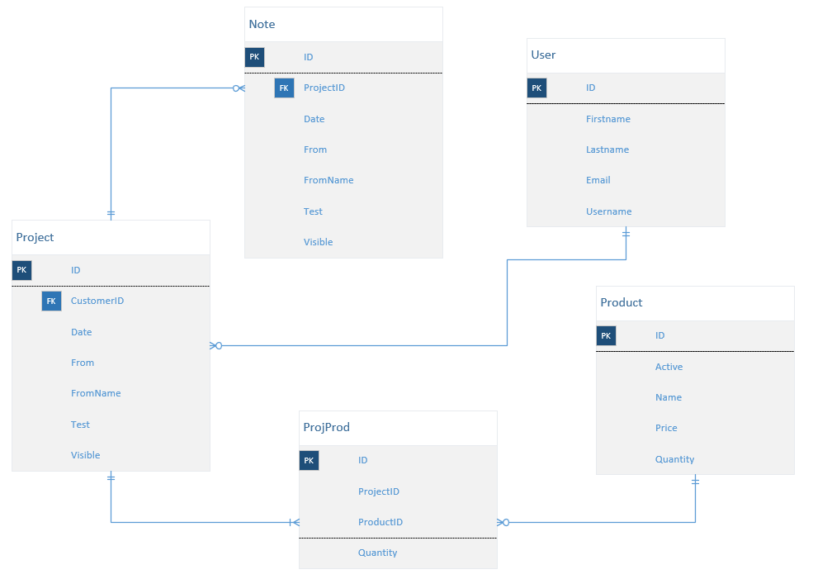

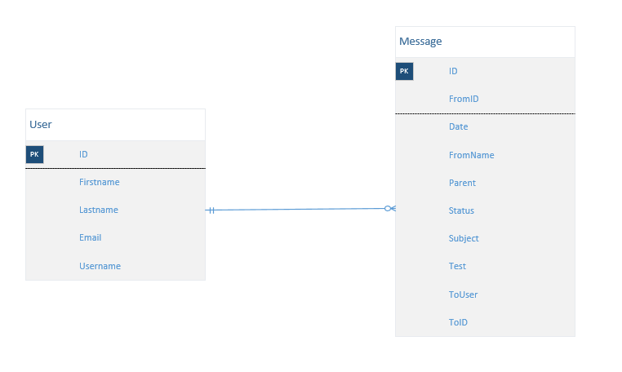

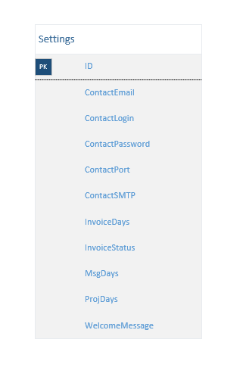

**Use Cases**

|  |  |
| --- | --- |
| **Registration System** | |
| **Use Case** | **Actors** |
| Click the Register button | User |
| Retrieves form | System |
| Fills out form | User |
| Clicks Submit button | User |
| Saves form | System |
| Loads redirected (Welcome) page | System |

|  |  |
| --- | --- |
| **Login System** | |
| **Use Case** | **Actors** |
| Click the Login button | User |
| Retrieves form | System |
| Fills out form | User |
| Clicks Submit button | User |
| Loads redirected (Welcome) page | System |

|  |  |
| --- | --- |
| **Logout System** | |
| **Use Case** | **Actors** |
| Click the Logout button | User |
| Loads redirected (Home) page | System |

|  |  |
| --- | --- |
| **Contact System** | |
| **Use Case** | **Actors** |
| Click the Contact tab | User |
| Retrieves form | System |
| Fills out form | User |
| Clicks Submit button | User |
| Send email | System |
| Loads redirected (Thank You) page | System |

|  |  |
| --- | --- |
| **View Messages System** | |
| **Use Case** | **Actors** |
| Click the Account tab | User |
| Expand drop down list | System |
| Click the View Messages option | User |
| Retrieves page with list of messages | System |

|  |  |
| --- | --- |
| **Send Messages System** | |
| **Use Case** | **Actors** |
| Click the Account tab | User |
| Expand drop down list | System |
| Click the Send Messages option | User |
| Retrieves form | System |
| Fills out form | User |
| Clicks submit button | User |
| Retrieves page with list of messages | System |

|  |  |
| --- | --- |
| **View Projects System** | |
| **Use Case** | **Actors** |
| Click the Account tab | User |
| Expand drop down list | System |
| Click the View Projects option | User |
| Retrieves page with list of projects | System |

|  |  |
| --- | --- |
| **Request Projects System** | |
| **Use Case** | **Actors** |
| Click the Account tab | User |
| Expand drop down list | System |
| Click the Request Project option | User |
| Retrieves form | System |
| Fills out form | User |
| Clicks submit button | User |
| Retrieves page with list of projects | System |

**Use Case Diagrams**

Registration System Use Case Diagram

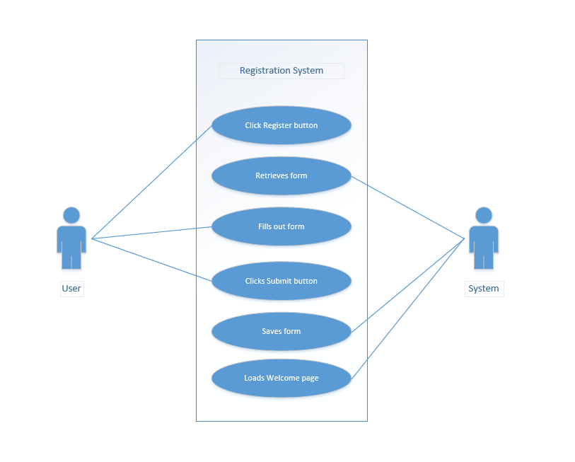

Login System Use Case Diagram

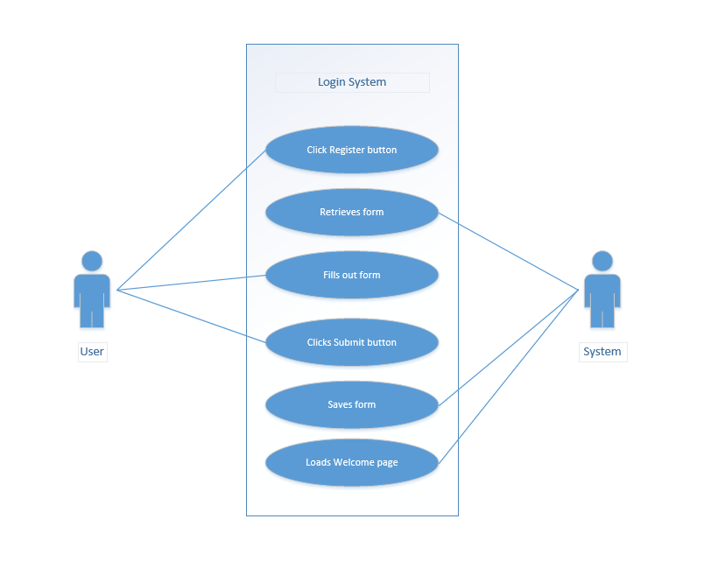

Logout System Use Case Diagram

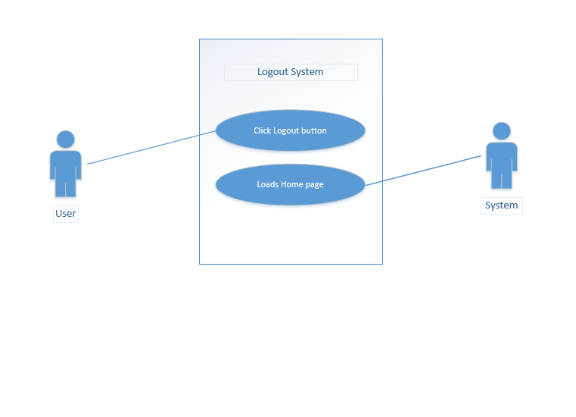

Contact System Use Case Diagram

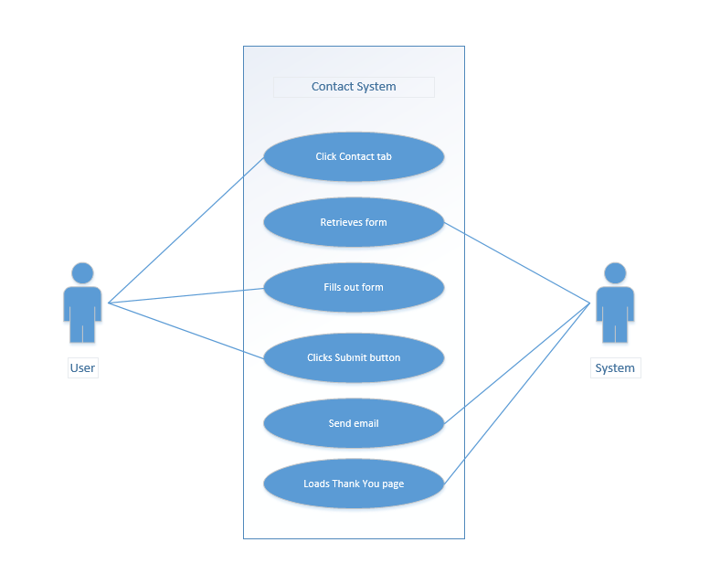

View Messages System Use Case Diagram

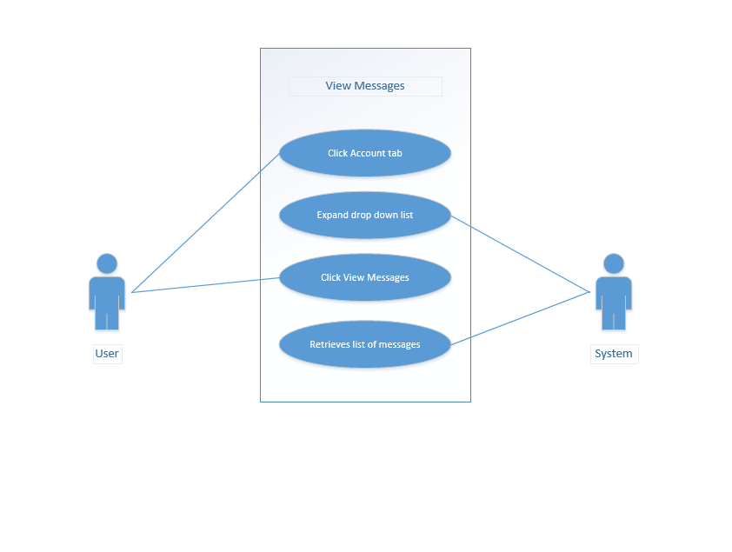

Send Messages System Use Case Diagram

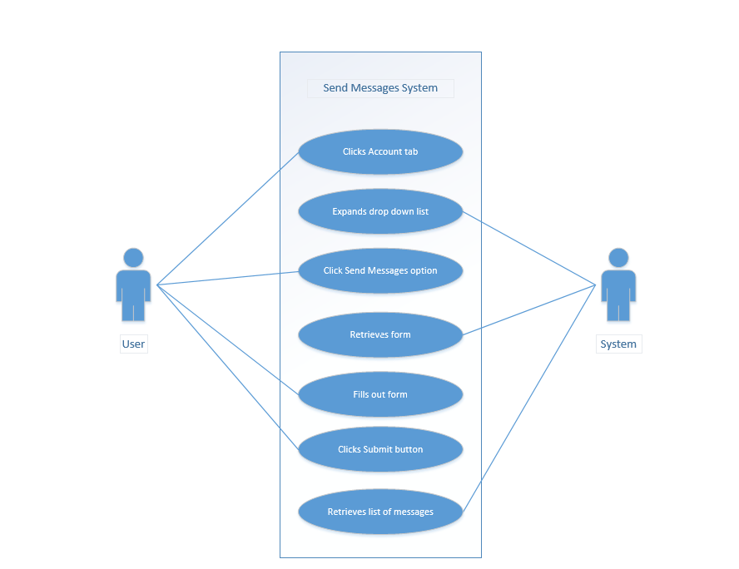

View Projects System Use Case Diagram

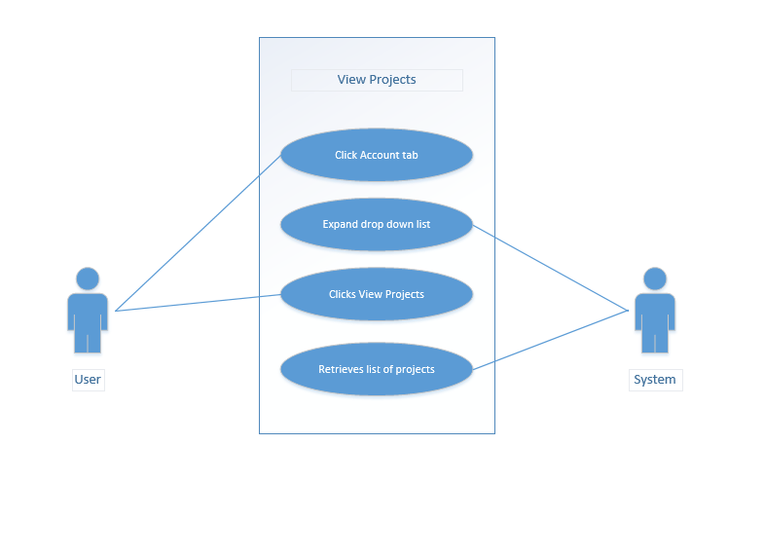

Request Projects System Use Case Diagram

